FHD MTP® 24 Cassettes Datasheet

FHD Fiber Optic MTP® Cassettes consist of pre-terminated LC, SC or MDC adapters for quick and easy deployment in high density applications and provide efficient utilization of rack space and design flexibility.
The cassettes interconnect with high-density fiber cable assemblies for quick connection of remote or data center applications.
Features
• High-density modular design, up to 144 fibers (LC) in 1U for efficient utilization.
• Pre-terminated cassette for improved reliability and quick deployment.
• High performance connectors to achieve a low loss optical budget.
• Plug-N-play modules allow fast installation of multiple fiber links.
• Offered in a wide range of performance and polarity configurations.
• The corning fiber compliant to Telcordia, EIA/TIA and IEC standards
Product Constructions
Fiber Count 12 Fibers/24 Fibers/36 Fibers/48 Fibers/96 Fibers
Fiber Mode Multimode: OM3 50/125μm and OM4 50/125μm
Single Mode: OS2 9/125μm
Front Connector Multimode: LC/SC Duplex with UPC Polish Single Mode: LC/SC Duplex with UPC/APC Polish. MDC Duplex with UPC Polish
Rear Connector Multimode: MTP® Adapter(s) with Male Ferrules (pins) and UPC Polis. Single Mode: MTP® Adapter(s) with Male Ferrules (pins) and APC Polish
Polarity Type Type A/AF/B1/B2/Universal
Material Aluminum (AL5052)
Dimensions (HxWxD) 1.38''x4.29''x4.64'' (35x109x118mm)
Performance Properties
Rear Connector US Conec MTP®
Insertion Loss Multimode: Stand IL 0.6dB max. Ultra-Low IL 0.35dB Max.
Single Mode: Stand IL 0.75dB Max. Ultra-Low IL 0.35dB Max.
Return Loss Multimode: ≥20dB Single Mode: ≥60dB
Connector Durability US Conec MTP® Connector Meets TIA/EIA-568. C.3A.4.9 Durability: 500 Mating Cycles
Front Connector LC/SC/MDC Duplex
Fiber Mode Multimode/Single Mode
Material of Sleeve Zirconia Ceramic
Insertion Loss Multimode: UPC ≤0.2dB and Single Mode: APC ≤0.3dB
UPC ≤0.2dB
Return Loss Multimode: UPC ≥30dB and Single Mode: APC ≥60dB
UPC ≥50dB
Note:
The US Conec MTP® connectors are fully compliant with the MPO standards, achieving higher performance levels when compared to generic MPO connectors.
Environmental Characteristics
Operating Temperature -10℃-60℃
Storage Temperature -10℃-60℃
Standards Compliance
• ISO9001 Certificate
• RoHS Compliant
• WEEE Compliant
PRODUCTS
2X12 MTP OM4 SERIES
P/N I-2X12FOM3LM-CAS-MA (This is for a 24F MTP (MALE) TO LC CASSETTE METHOD A). Description: 24F (12x2 MTP) to LC in OM3, OM4 & OS2. MA = MALE METHOD A.
Replace the OM3 with OM4 or change the suffix to SM for OS2.
NOTE: MB = MALE METHOD B for all cassette configurations. If you want Male Method B it will be -MB. If you want to order a Female Method B change the suffix to -FB (Similarly, to order a Female method A change the suffix to -FA).
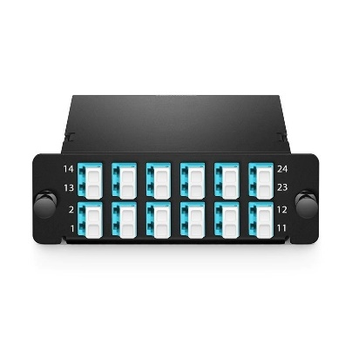FHD MTP® to LC Cassette, 24 Fibers OM4, Type A, 0.35dB max. FHD MTP®-24 Cassette, 24 Fibers OM4 Multimode, Type A, MTP® to 12 x LC Duplex (Aqua), 0.35dB max.

2X12 MTP OS2 SERIES
P/N I-2X12FOS2LM-CAS-MA (2x12 MTP(M)-LC CASSETTE MEHOD A). Change OS2 in the P/N , to OM3 & OM4 to represent those items. MB FOR METHOD B.
Description: 24F (12x2 MTP) to LC in OM3, OM4 & OS2. METHOD A & METHOD B
NOTE: MB = MALE METHOD B for all cassette configurations. If you want Male Method B it will be -MB. If you want to order a Female Method B change the suffix to -FB (Similarly, to order a Female method A change the suffix to -FA).
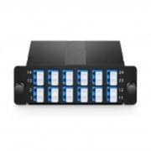FHD MTP® to LC Cassette, 24 Fibers OS2, Universal Polarity, 0.35dB max. FHD 3 x MTP®-8 Cassette, 24 Fibers OS2 Single Mode, Universal Polarity, 3 x 8F MTP® to 6 x LC Quad (Blue), 0.35dB max

2x12 MTP OM3 SERIES
P/N I-2X12FOM3LM-CAS-MA (2x12 OM3 MTP(M)-LC CASSETTE METHOD A) Change OM3 to OM4 and OS2 to represent OM4 and SM respectively. MB FOR METHOD B.
Description: 24F (12x2 MTP) to LC in OM3, OM4 & OS2. METHOD A & METHOD B
NOTE: MB = MALE METHOD B for all cassette configurations. If you want Male Method B it will be -MB. If you want to order a Female Method B change the suffix to -FB (Similarly, to order a Female method A change the suffix to -FA).
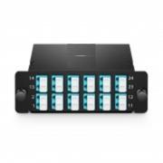FHD 3 x MTP®-8 Cassette (Color-coded), 24 Fibers OM3 Multimode, Universal Polarity, 3 x 8F MTP® to 6x LC Quad (Aqua), 0.35dB max

2X12 MTP OS2 SERIES
P/N: I-2X12FOS2LM-CAS-MA (to represent 2x12 SM MTP(M)-LC CASSETTE METHOD A). Same goes for the others (change OS2 to OM3 and OM4 to represent those types of cassettes). MB FOR METHOD B.
Description: 24F (12x2 MTP) to LC in OM3, OM4 & OS2. METHOD A & METHOD B
NOTE: MB = MALE METHOD B for all cassette configurations. If you want Male Method B it will be -MB. If you want to order a Female Method B change the suffix to -FB (Similarly, to order a Female method A change the suffix to -FA).

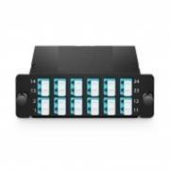FHD MTP®-24 Cassette (Color-coded), 24 Fibers OM3 Multimode, Type A, MTP® to 12 x LC Duplex (Aqua), 0.35dB max

2X12 MTP OM4 SERIES
P/N I-2X12FOM4LM-CAS-MA (2x12F OM4 MTP(M)-LC CASSETTE.
Description: 24F (12x2 MTP) to LC in OM3, OM4 & OS2. METHOD A & METHOD B
NOTE: MB = MALE METHOD B for all cassette configurations. If you want Male Method B it will be -MB. If you want to order a Female Method B change the suffix to -FB (Similarly, to order a Female method A change the suffix to -FA).

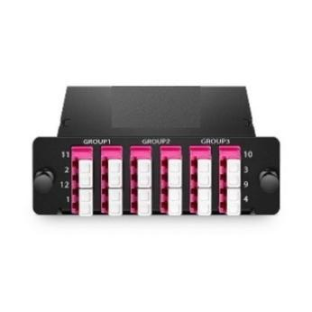FHD 3 x MTP®-8 Cassette (Color-coded), 24 Fibers OM4 Multimode, Universal Polarity, 3 x 8F MTP® to 6x LC Quad (Magenta), 0.35dB max

2X12 MTP-OS2 SERIES
P/N I-2X12FOS2LM-CAS-MA (2x12 SM MTP(M)-LC METHOD A). Description: 24F (12x2 MTP) to LC in OM3, OM4 & OS2. METHOD A & METHOD B
NOTE: MB = MALE METHOD B for all cassette configurations. If you want Male Method B it will be -MB. If you want to order a Female Method B change the suffix to -FB (Similarly, to order a Female method A change the suffix to -FA).

